Test Case Document

Prepared for: WireApps Ltd

Prepared by: Asheni Sandeepa

Document: QA Technical Assessment

|  |  |  |  |  |  |  |
| --- | --- | --- | --- | --- | --- | --- |
| **Test Case ID** | **Test Case Title** | **Description** | **Steps to Reproduce** | **Expected Result** | **Test Result**  **(pass/fail)** | **Screen Shot** |
| **1** | Translation Accuracy - Basic Text | Verify accurate translation of a simple English sentence to Sinhala. | 1. Navigate to<https://translate.google.com/>.  2. Enter "Hello, how are you?" for translation to Sinhala. | The translated Sinhala text accurately conveys the meaning of the original English sentence. | pass |  |
| **2** | Translation Accuracy - Complex Text | Verify accurate translation of a complex Sinhala paragraph to English. | 1. Navigate to<https://translate.google.com/>.  2. Enter a complex Sinhala paragraph for translation to English. | The translated English text accurately conveys the meaning of the original Sinhala paragraph. | Pass-  But the meaning changes for some extent |  |
| **3** | Language Detection | Verify correct language detection of input text. | 1. Navigate to<https://translate.google.com/>.  2. Enter mixed-language text for translation. | Google Translate accurately detects the languages used in the input text. | pass |  |
| **4** | Special Characters Handling | Verify correct handling of special characters and symbols. | 1. Navigate to<https://translate.google.com/>.  2. Enter text containing special characters, emojis, or symbols. | The translated text preserves the special characters, emojis, and symbols from the original text. | Pass the characters are not displayed |  |
| **5** | Pronunciation Feature | Verify functionality of the pronunciation feature. | 1. Navigate to<https://translate.google.com/>.  2. Enter a word or phrase in any supported language.  3. Click on the speaker icon for pronunciation. | The pronunciation feature accurately pronounces the entered word or phrase. | pass |  |
| **6** | Translation History | Verify maintenance of translation history. | 1. Navigate to<https://translate.google.com/>.  2. Enter and translate multiple texts.  3. Check translation history. | The translation history displays all previously translated texts in chronological order. | pass |  |
| **7** | Input Text Limit | Verify maximum character limit for input text. | 1. Navigate to<https://translate.google.com/>.  2. Attempt to enter a text exceeding the character limit. | Google Translate displays an error or warning message indicating the character limit has been exceeded. | Pass-5000 is the character limit |  |
| **8** | Spell Check | Verify presence of spell check feature for input text. | 1. Navigate to<https://translate.google.com/>.  2. Enter text with intentional spelling errors for translation. | Google Translate underlines misspelled words and offers suggestions for corrections. | pass |  |
| **9** | Translation of Website Content | Verify accurate translation of website content. | 1. Navigate to a website with foreign language content.  2. Use Google Translate to translate the webpage. | The translated webpage accurately conveys the meaning of the original content. | pass |  |
| **10** | Mobile Device Compatibility | Verify functionality on mobile devices. | 1. Access Google Translate using a mobile device.  2. Enter and translate text using mobile browser or app. | Google Translate is fully functional and provides accurate translations on mobile devices. | pass |  |
| **11** | Sinhala to English Translation - Basic Word | Verify accurate translation of a basic Sinhala word to English. | 1. Navigate to<https://translate.google.com/>.  2. Enter the Sinhala word "ආයුබෝවන්" for translation to English. | The translated English text should be "Hello" which accurately conveys the meaning of the original Sinhala word. | pass |  |
| **12** | Tamil to English Translation - Basic Word | Verify accurate translation of a basic Tamil word to English. | 1. Navigate to<https://translate.google.com/>.  2. Enter the Tamil word "வணக்கம்" for translation to English. | The translated English text should be "Hello" which accurately conveys the meaning of the original Tamil word. | pass |  |
| **13** | English to Sinhala Translation - Basic Word | Verify accurate translation of a basic English word to Sinhala. | 1. Navigate to<https://translate.google.com/>.  2. Enter the English word "Mother" for translation to Sinhala. | The translated Sinhala text should be "අම්මා" which accurately conveys the meaning of the original English word. | pass |  |
| **14** | English to Tamil Translation - Basic Word | Verify accurate translation of a basic English word to Tamil. | 1. Navigate to<https://translate.google.com/>  2. Enter the English word "Mother" for translation to Tamil. | The translated Tamil text should be "அம்மா" which accurately conveys the meaning of the original English word. | pass |  |
| **15** | Sinhala to Tamil Translation - Basic Word | Verify accurate translation of a basic Sinhala word to Tamil. | 1. Navigate to<https://translate.google.com/>.  2. Enter the Sinhala word " අම්මා " for translation to Tamil. | The translated Tamil text should be "அம்மா" which accurately conveys the meaning of the original Sinhala word. | pass |  |

Performance Testing Done Using Different Tools  
  
  
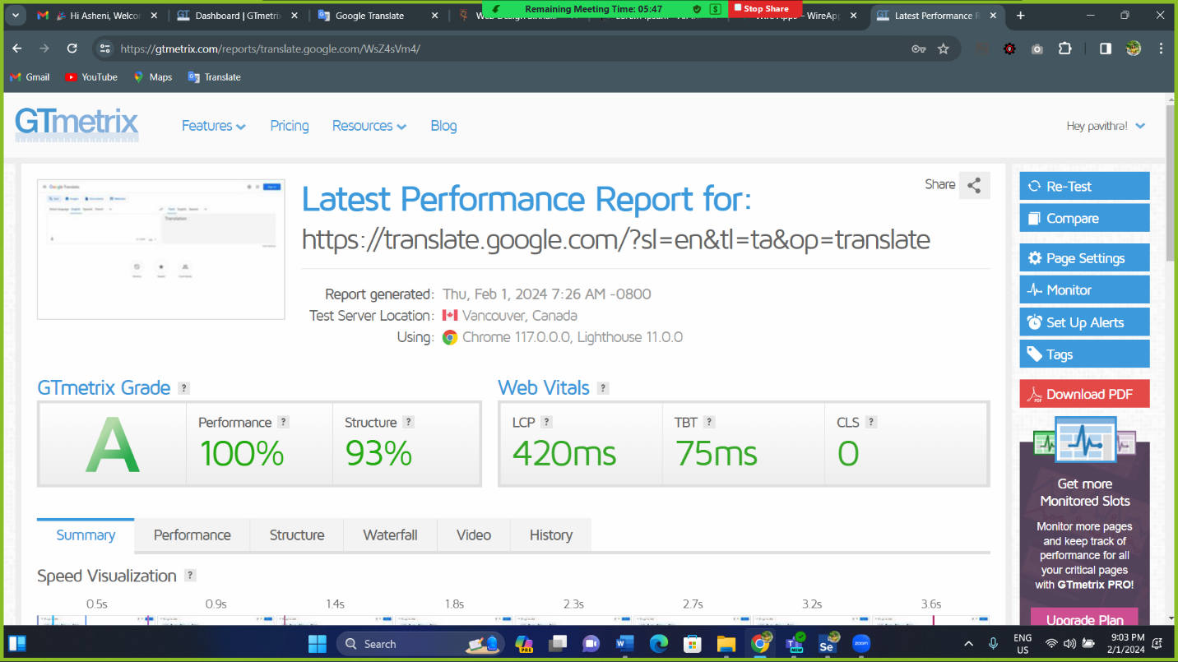

performance testing using gtmetrix

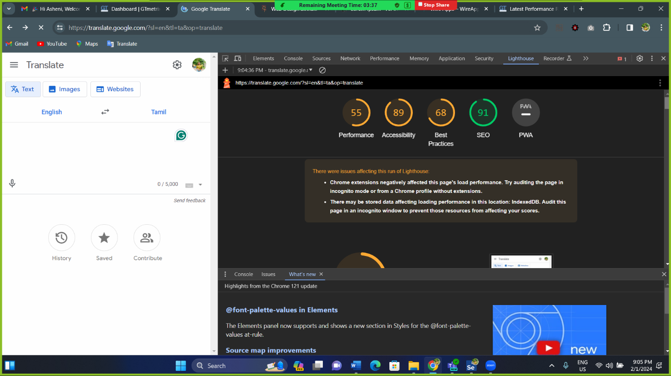

performance testing using light house

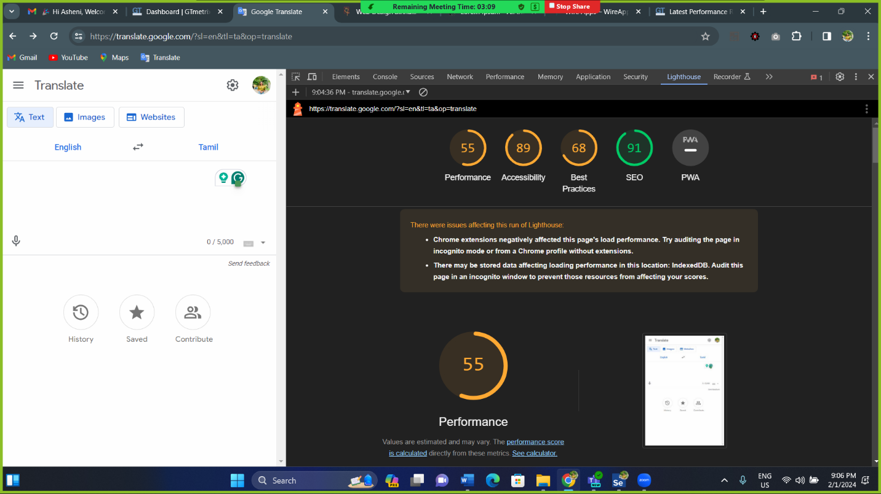

performance testing using light house

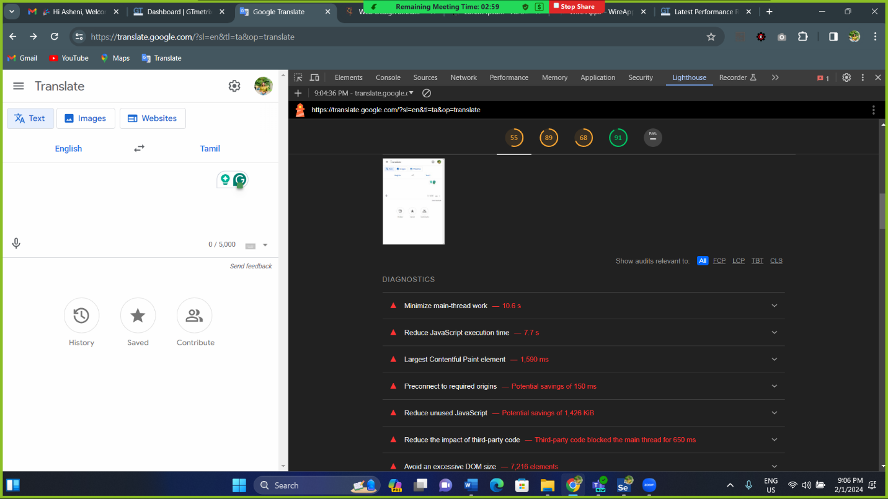

performance testing using light house

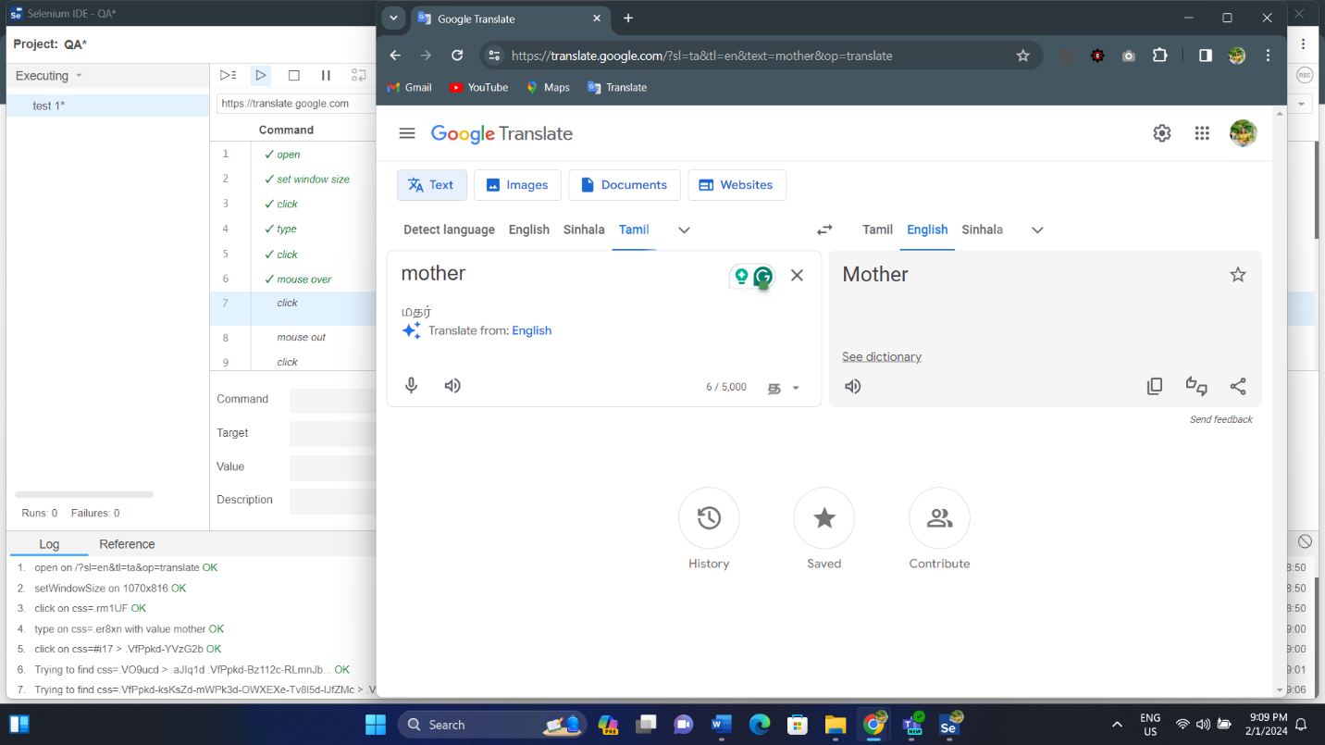

test case testing using selenium IDE

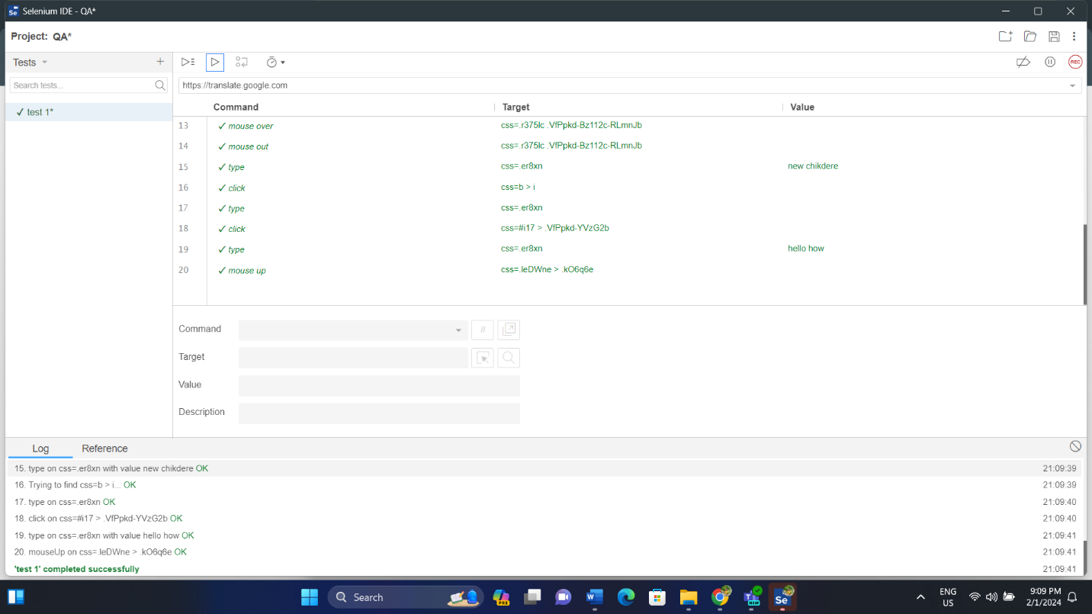

Test case testing using selenium IDE